CIS 4911 – SENIOR PROJECT

Picture Marketing’s Social Wall Ver. 2.0

Installation Guide Document

Members: Steve Noel

Mentor: Carlos Ocampo

Instructor: Masoud Sadjadi

**Installing Project**

1) Download project Source code from Github at <https://github.com/FIU-SCIS-Senior-Project-2015-Spring/Social-Wall-Ver-2.0.git> this will create a folder called Social Wall Ver-2.0 with the necessary files.

2) All source code of the project is in the Code directory of the folder. All web application files are in the Website sub folder and the mobile application files are in the Mobile Application sub folder. Look at the diagram below.

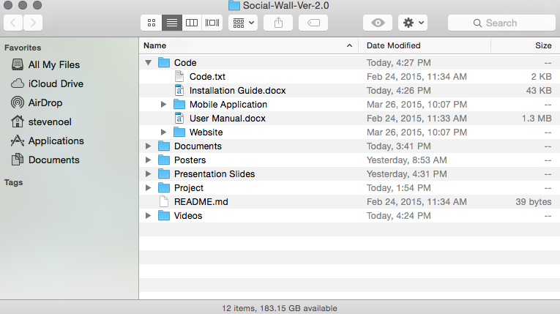

3) The source code for the web application can be found inside the Website/app/finalReceiver folder and Mobile application source code are in the Mobile Application/seniorProjectApp folder.

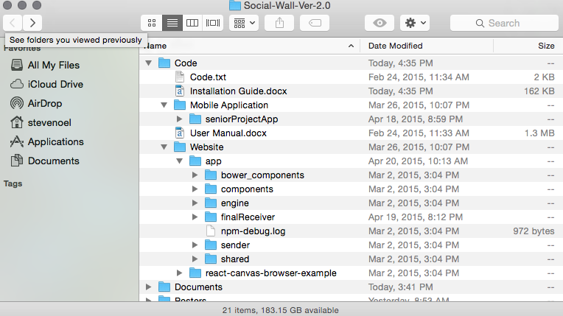

**Setting up Mobile Application Project**

1) Sencha Touch

Sencha touch was the framework used to develop the Application. It must be used to build the app in order to see your changes. It also works with the native packager cordova to package your app as a hybrid app. So you must have sencha touch installed on your development machine to make modifications to the app.

1.1) Sencha Touch 2.x Framework (latest version is 2.4)

There are two major major components of sencha touch. Sencha Cmd and the actual sencha touch framework. Sencha Cmd is a command line tool where you write your build commands on existing applications and the Sencha Framework is used to build new applications.

1.2) Installing the Sencha Framework

1) goto <https://www.sencha.com/products/touch/download/> fill out the survey and download the framework. It should be emailed to the email you specified. You will receive a folder called touch-xxx save this folder on your machine, if something happens you can always create a new app using it.

1.4) Install Java Runtime Environment

version 1.7. Sencha Cmd is written in Java and needs the JRE to run. **Note**: If you are building an Android app using Windows, you must install the [Java SDK](http://www.oracle.com/technetwork/java/javase/downloads/jdk7-downloads-1880260.html). You can build an iOS app under Windows with the JRE, but not an Android app.

1.5) Install Ruby

Ruby is used to create the compiled CSS used by Sencha Touch.

Windows users Download ruby from rubyinstaller.org . Download the RubyInstaller .exe file and run it . Mac users ruby is preinstalled in system.

1.3) Installing Sencha Cmd

1) goto <https://www.sencha.com/products/sencha-cmd/> click the download button and follow the instructions to install it on your system.

2) After installing you should have a global sencha command. Type “sencha” into terminal to make sure the installation was successful you should see something like the image below if not try installing again.

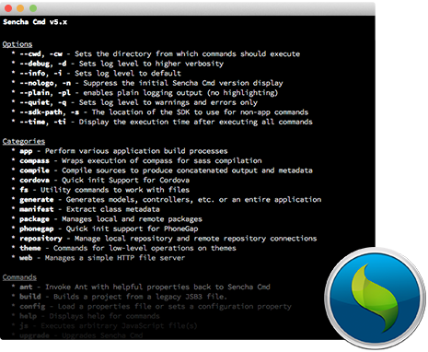

2) Setting Up Cordova

Cordova is the app packager that converts the sencha app into a hybrid application that can be run on a mobile device. It must be setup in order to run the app on the device and simulator.

2.1) NodeJs

Nodejs is used to install cordova on your system.

Goto <https://nodejs.org/download/> and download the nodejs installer for your system this will also download npm for you which is crucial.Follow the instructions on the installer. Type “npm” into terminal to make sure it is installed on your system. Also type “node” into terminal to make sure you have it installed.

2.2) Install Cordova

1) type “npm install -g cordova” into terminal to install cordova globally on your system you may need to type “sudo” first to make the command work. Type cordova in terminal to make sure you have it installed you should see a list of option if not try installing again.

2.3 Xcode

The IOS application requires the Xcode Development environment. Go the to Mac App Store and search Xcode and download the software.

**Setting up IOS Application**

1) The IOS Xcode project can be found at Code/Mobile Application/seniorProjectApp/cordova/platforms/ios it is the file with the .xcodeproj file extension. If the cordova folder does not exist run the following commands in your terminal in the seniorProjectApp directory:

* sencha cordova init com.wall.fotozap Slideshow
* (inside cordova folder) cordova platform add ios

(inside cordova folder)

cordova plugin add https:*//github.com/ConnectSDK/Connect-SDK-Cordova-Plugin.git#master*

2) Clone the Connect SDK IOS github repository at <https://github.com/ConnectSDK/Connect-SDK-iOS.git>

3)

|  |  |  |  |  |  |  |  |  |  |
| --- | --- | --- | --- | --- | --- | --- | --- | --- | --- |
| Set up the submodules by running the following commands in Terminal in the Connect-SDK-iOS  directory of the cloned repository from step 3  git submodule init  git submodule update  5) Open the .xcodeproj ( file from step 1 ) the main xcode project in Xcode.  6) Drag the Connect SDK Xcode project ( the .xcodeproj file from step 2) into your main project's  Xcode library.  7) Navigate to your project's settings screen, then navigate to the Build Phases  tab.  8) Add ConnectSDK as a Target Dependency.  9)   |  |  | | --- | --- | | add the following in the Link Binary With Libraries section  libConnectSdk.a  libz.dylab |  | | Libicucore.dylab  10) Navigate to the Build Settings tab and add -ObjC to your target's Other  Linker Flags  11) Build and run the Project on Xcode on the emulator. | libConnectSDK.a | |  | libz.dylib | |  | libicucore.dylib | |  |
|  | git submodule init |
|  | git submodule update |

**Setting up Connect SDK Chrome cast IOS Framework**

1.Go to the Google Cast Developer site (https://developers.google.com/cast/docs/downloads ) and download the iOS sender library

2.Extract the GoogleCast.framework bundle from the downloaded ZIP file

3. Move the framework bundle into your google-cast folder in the Connect SDK IOS folder the folder you cloned in step 2 .

4. Add GoogleCast.framework and MediaAccessibility.framework to Link Binary With Libraries section and drag GoogleCast.framework to the Frameworks folder of your main xcode project.

5. Build and Run your Application.

**Setting up Website**

1) Simply place the index.html file and the scripts/ directory from the Code/Website/app/finalReceiver folder into your local server web directory and open browser to localhost.